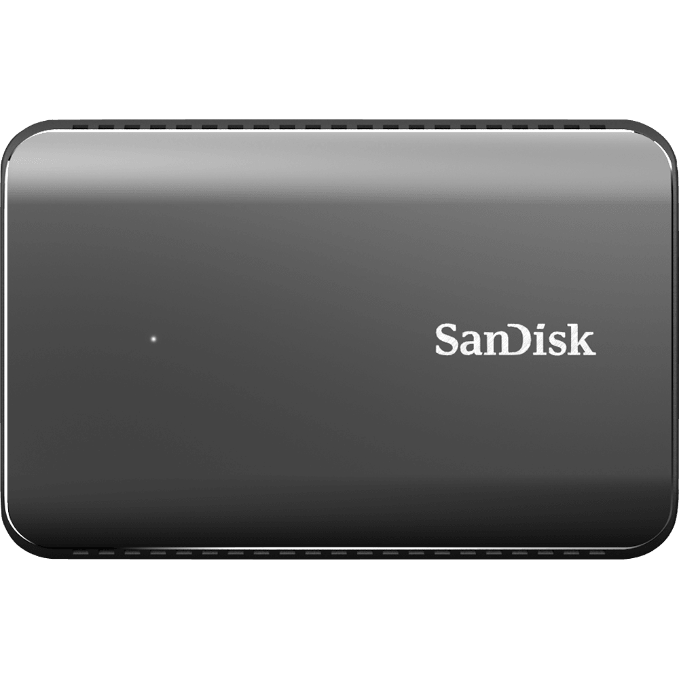

HIGH-SPEED STORAGE FOR HIGH-RES PHOTOS AND VIDEOS

Looking for serious storage speeds for your photos, videos and files? The SanDisk Extreme 900 portable SSD delivers up to 9x faster speeds than a portable hard drive[2](https://www.sandisk.com/home/ssd/extreme-900-ssd#footnotes) in up to 1.92TB[1](https://www.sandisk.com/home/ssd/extreme-900-ssd#footnotes) capacities to move your massive files in seconds. Working directly on the drive is more efficient too with faster access times. With solid state technology, there are no moving parts to break or overheat. SanDisk SecureAccess™ encryption software keeps your files private[3](https://www.sandisk.com/home/ssd/extreme-900-ssd#footnotes). When your livelihood depends on it, trust the brand professionals rely on with SanDisk Extreme 900 portable SSD.

* **Capacity:** 1.92 TB
* **Read Speed:** up to 850 MB/s[7](https://www.sandisk.com/home/ssd/extreme-900-ssd#footnotes)
* **Write Speed:** up to 850 MB/s[7](https://www.sandisk.com/home/ssd/extreme-900-ssd#footnotes)
* **Interface:** USB 3.1 Gen 2